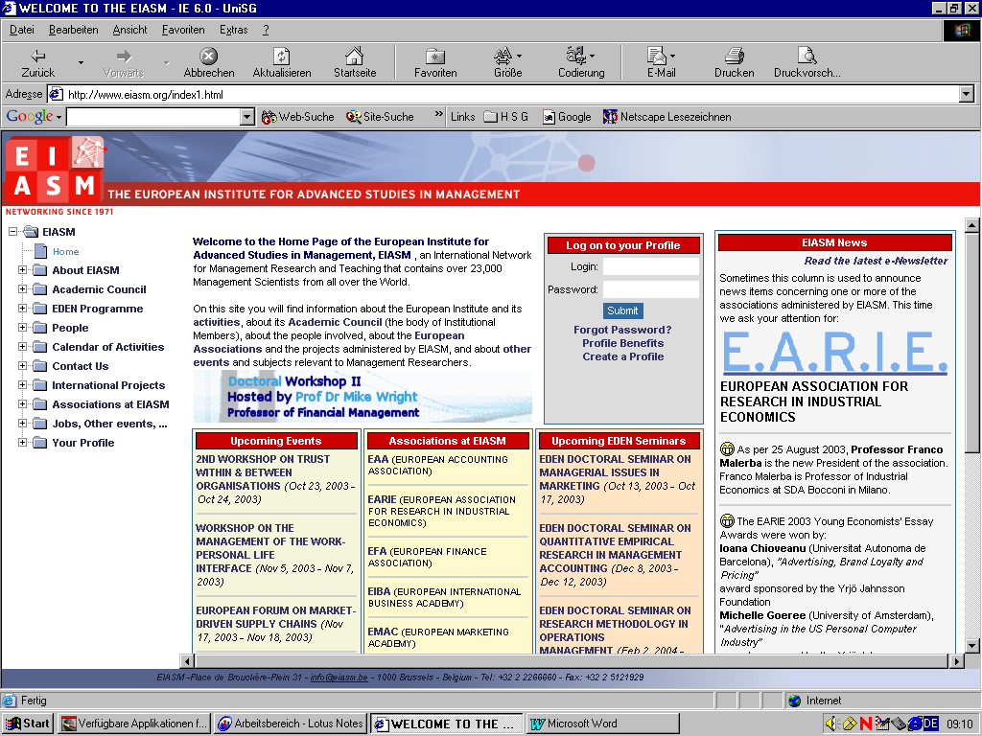
PLACE DE BROUCKÈRE-PLEIN - 31 - 1000 BRUSSELS - BELGIUM - Tel: 32 2 2266660 - Fax: 32 2 5121929

12th Workshop on Corporate Governance
Brussels, Belgium
October 29-30, 2015
Chairpersons :
Tomas CASAS KLETT - International Center for Corporate Governance, Shanghaï, China
Hugh GROVE - University of Denver, USA
Martin HILB (Coordinating Chairperson) - University of St. Gallen, Switzerland
Morten HUSE - Reinhard-Mohn-Chair University of Witten/Herdecke, Germany & BI Norwegian Business School, Norway
PROGRAMME

Thursday October 29, 2015
Registration | 09:00 – 09:40
ROOM : MEC AUDI 2  Introduction by the Chairpersons | 09:40 – 10:40
Coffee Break | 10:40 - 11:10
ROOM : MEC AUDI 2  TRACK A: Strategic Control  Chairperson : Hugh GROVE - USA |  | ROOM : BOURGMESTRES  TRACK B: International Corporate Governance  Chairpersons :  A.M. - Morten HUSE - Norway  P.M. - Martin HILB - Switzerland
AUDIT COMMITTEE EFFECTIVENESS, AUDIT QUALITY, AUDIT REPORT DELAY AND FIRM PERFORMANCE IN SOME GCC COUNTRIES  AL-MOATAZ EHSAN SALEH, (UMM AL-QURA UNIVERSITY - SAUDI ARABIA) -. KHALED ALJAAIDI | 11:10 – 11:40 | REASSESSING GOVERNANCE RESEARCH: A RETURN TO FIRST PRINCIPLES  CROW PETER, (MASSEY UNIVERSITY - NEW ZEALAND) - JAMES LOCKHART
PENDING LEGAL RESPONSIBILITIES OF NON-EXECUTIVE BOARDS FOR VERNANCE IN INFORMATION SECURITY  GEORG LAURA, (GJOVIK UNIVERSITY COLLEGE - NORWAY) - | 11:40 – 12:10 | CORPORATE GOVERNANCE OF SME’S AND BRANDING STRATEGIES  BAKKOUR MAHMOUD, (INRA - NATIONAL INSTITUTE FOR AGRONOMIC RESEARCH - FRANCE) - FATIHA FORT - ANNE MIONE
Lunch | 12:10 – 14:00 | Lunch
CORPORATE GOVERNANCE, PERFORMANCE AND RISK: CONTRIBUTIONS FOR A RESEARCH MODEL  RODRIGUES RICARDO, (LISBON UNIVERSITY - PORTUGAL) - | 14:00 – 14:30 | PRIVATE EQUITY AND VALUE-BASED MANAGEMENT PRACTICES: THE ROLE OF PARTNERS.  DELLO SBARBA ANDREA, (UNIVERSITY OF PISA - ITALY) - RICCARDO GIANNETTI - ALESSANDRO MARELLI
RELATED PARTY TRANSACTIONS AND CORPORATE GOVERNANCE: IS THE DISCLOSURE GOOD ENOUGH TO PROTECT MINORITIES?  MEDIOLI ALICE, (UNIVERSITY OF PARMA - ITALY) - PAOLO ANDREI - PIER LUIGI MARCHINI | 14:30 – 15:00 | ASSISTANCE OR HINDRANCE? EXPLORING THE EFFECT OF OWNERSHIP STRUCTURE IN PRIVATE FAMILY FIRMS  CHE LIMEI, (BI NORWEGIAN BUSINESS SCHOOL - NORWAY) - ZHANG, PINGYING
Coffee/Tea Break | 15:00 – 15:30 | Coffee/Tea Break
RELATED PARTY TRANSACTIONS AND EARNINGS MANAGEMENT:  AN EMPIRICAL ANALYSIS IN ITALIAN LISTED COMPANIES  MARCHINI PIER LUIGI, (UNIVERSITY OF PARMA - ITALY) - TATIANA MAZZA, ALICE MEDIOLI | 15:30 – 16:00 | CORPORATE GOVERNANCE EFFECTIVENESS AND VALUE CREATION: THE ROLE OF PRIVATE EQUTY  DI TOMA PAOLO, (UNIVERSITY OF MODENA AND REGGIO EMILIA - ITALY) -
THE DETERMINANTS OF LEVERAGE DURING FINANCIAL MARKETS MELTDOWN FOR BANK CENTERED PRIVATELY HELD CORPORATIONS  KHALFAN TWAHIR, (REYKJAVÍK UNIVERSITY - ICELAND) - | 16:00 – 16:30 | STRATEGIC OVERSIGHT OF BOARDS IN EMERGING CAPITAL MARKET OF RUSSIA. DOES CORPORATE PERFORMANCE MATTER FOR THE CHANGES IN THE BOARDS AND THE DISMISSAL OF CEO?  IVASHKOVSKAYA IRINA, (HIGHER SCHOOL OF ECONOMICS - RUSSIA) - ANASTASIA STEPANOVA - ANASTASIA SUCHKOVA
 | 17:00 – 18:30 | CORPORATE GOVERNANCE RESEARCH NETWORK MEETING

WORSHOP DINNER  “Aux Armes de Bruxelles” - Rue des Bouchers, 13 | 19:00

Friday, October 30, 2015 :
ROOM : MEC AUDI 2  TRACK C: Human Resource Governance  Chairpersons :  A.M. - Morten HUSE - Norway  P.M. - Martin HILB - Switzerland |  | ROOM : BOURGMESTRES  TRACK B: Strategic Direction  Chairperson : Tomas CASAS KLETT - China
RISK GOVERNANCE IN UK FINANCIAL SERVICES FIRMS  RUSSELL PETER, (UNIVERSITY OF EAST ANGLIA - U.K.) - IAN DEWING | 09:00 – 09:30 | BOARD COMPOSITION, FIRM CHARACTERISTICS AND FORWARD-LOOKING INFORMATION DISCLOSURE:EMPIRICAL EVIDENCE.  AGYEI-MENSAH BEN KWAME, (SOLBRIDGE INTERNATIONAL SCHOOL OF BUSINESS - SOUTH KOREA) -
A MULTILEVEL ASSESSMENT OF CORPORATE GOVERNANCE PERFORMANCE  BAR-HAIM AVIAD, (OPEN UNIVERSITY OF ISRAEL - ISRAEL) - ORR KARASSIN | 09:30 – 10:00 | EFFECTS OF COGNITIVE DIVERSITY ON STRATEGIC LENSES OF A COMPANY HAVING A DOMINANT POSITION IN THE MARKET: QUANTITATIVE EXPLORATORY STUDY OF TOP AND MIDDLE MANAGEMENT  BERGMAN JUKKA, (LAPPEENRANTA UNIVERSITY OF TECHNOLOGY - FINLAND) - JUKKA-PEKKA BERGMAN, VLADIMIR PLATONOV, IGOR DUKEOV, AND PEKKA RÖYTTÄ
Coffee Break | 10:00 – 10: 30 | Coffee Break
CONTRACTING WITH A QUIET-LIFE MANAGER  ALONSO-PAULI EDUARD, (UNIVERSITY OF THE BALEARIC ISLANDS - SPAIN) - | 10:30 – 11:00 | MULTIPLE AGENCY THEORY: AN ALTERNATIVE APPROACH TO BOARD RESEARCH  MERENDINO ALESSANDRO, (COVENTRY UNIVERSITY - U.K.) - GERRIT SARENS
BOARD ROLE PERFORMANCE AND FAULTLINES IN FAMILY FIRMS: THE MODERATING ROLE OF FORMAL BOARD EVALUATION  VANDEBEEK ALANA, (HASSELT UNIVERSITY - BELGIUM) - WIM VOORDECKERS - FRANK LAMBRECHTS - JOLIEN HUYBRECHTS | 11:00 – 11:30 | CORPORATE GOVERNANCE AND CHINESE GHOST CITIES  GROVE HUGH, (DENVER UNIVERSITY - U.S.A.) - MAC CLOUSE
THE ADOPTION OF PYRAMIDAL STRUCTURES  ALUCHNA MARIA, (WARSAW SCHOOL OF ECONOMICS - POLAND) - TOMASZ KUSZEWSKI | 11:30 – 12:00 | FROM OWNERS’ KNOWLEDGE VISION TO ORGANIZATIONAL PERFORMANCE  WAHL MIKE FRANZ, (TALLINN UNIVERSITY OF TECHNOLOGY - ESTONIA) -
Lunch | 12:00 – 13:30 | Lunch
ARE AUDIT COMMITTEES EFFECTIVE IN SAUDI ARABIA?  ALROQY FAISAL, (UMM AL-QURA UNIVERSITY - SAUDI ARABIA) - | 13:30 – 14:00 | CORPORATE GOVERNANCE OF BANKS IN WESTERN BALKAN: OVERVIEW OF CURRENT ISSUES AND CHALLENGES  HIMAJ SHKENDIJE, (UNIVERSITY OF LJUBLJANA - SLOVENIA) -
FROM SHAREHOLDER DEMOCRACY TO SHAREHOLDER VALUE: THE CASE OF SLOVENIAN CG OF STATE OWNED ENTERPRISES  RUS ANDREJ, (UNIVERSITY OF LJUBLJANA - SLOVENIA) - | 14:00 – 14:30 | A SURVEY OF THE FACTORS INFLUENCING THE CHOICE OF PERFORMANCE SYSTEMS IN FIRMS OPERATING IN KSA  AL-OMIRI MOHAMMED, (UMM AL-QURA UNIVERSITY - SAUDI ARABIA) -
Coffee/Tea Break | 14:30 – 15:00 | Coffee/Tea Break
Conclusions and lessons learned | 15:00 – 16:00

